TICTACTOE PROJECT

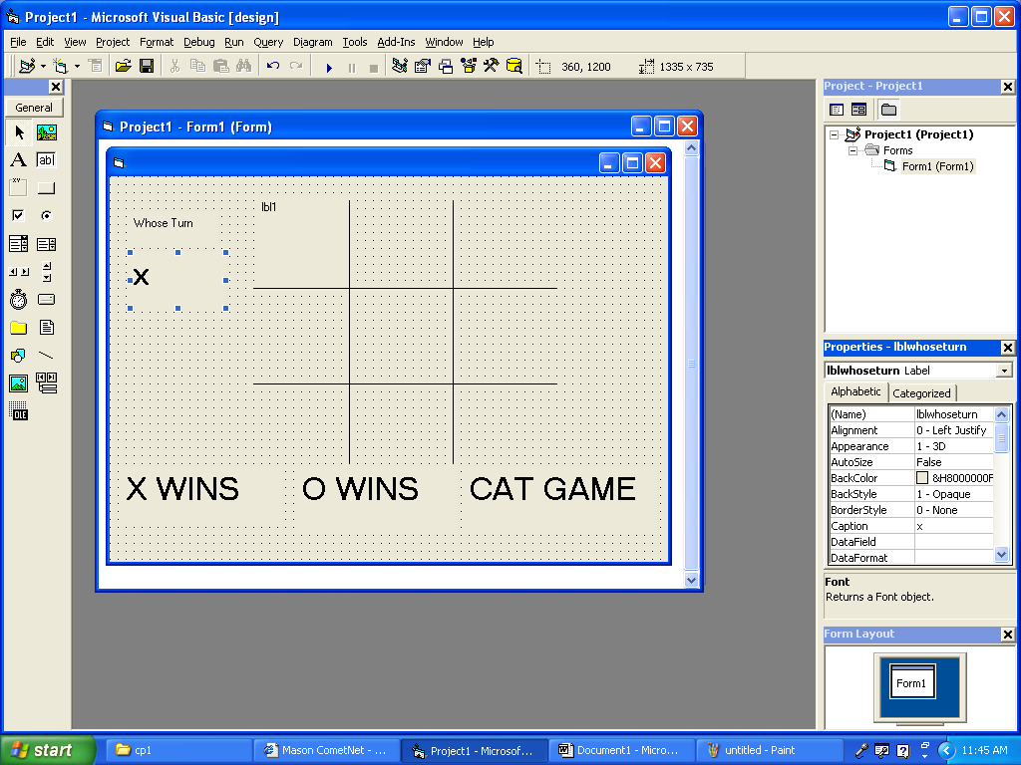

Private Sub lbl1_Click()

'play game

If lbl1 = "" Then

If lblwhoseturn = "x" Then

lbl1 = "x"

lblwhoseturn = "o"

Else

lbl1 = "o"

lblwhoseturn = "x"

End If

End If

'check to see if someone wins or ends game

If lbl3 = "x" And lbl2 = "x" And lbl1 = "x" Then

lblxwins.Visible = True

‘disable

‘lineth.visible=true

‘tmrxwins.enabled=true

‘lblnumxwins=val(lblnumxwins)+1

ElseIf lbl7 = "x" And lbl4 = "x" And lbl1 = "x" Then

lblxwins.Visible = True

'...all the other ways to end game by clicking on lbl1 last including cat game

End If

End Sub